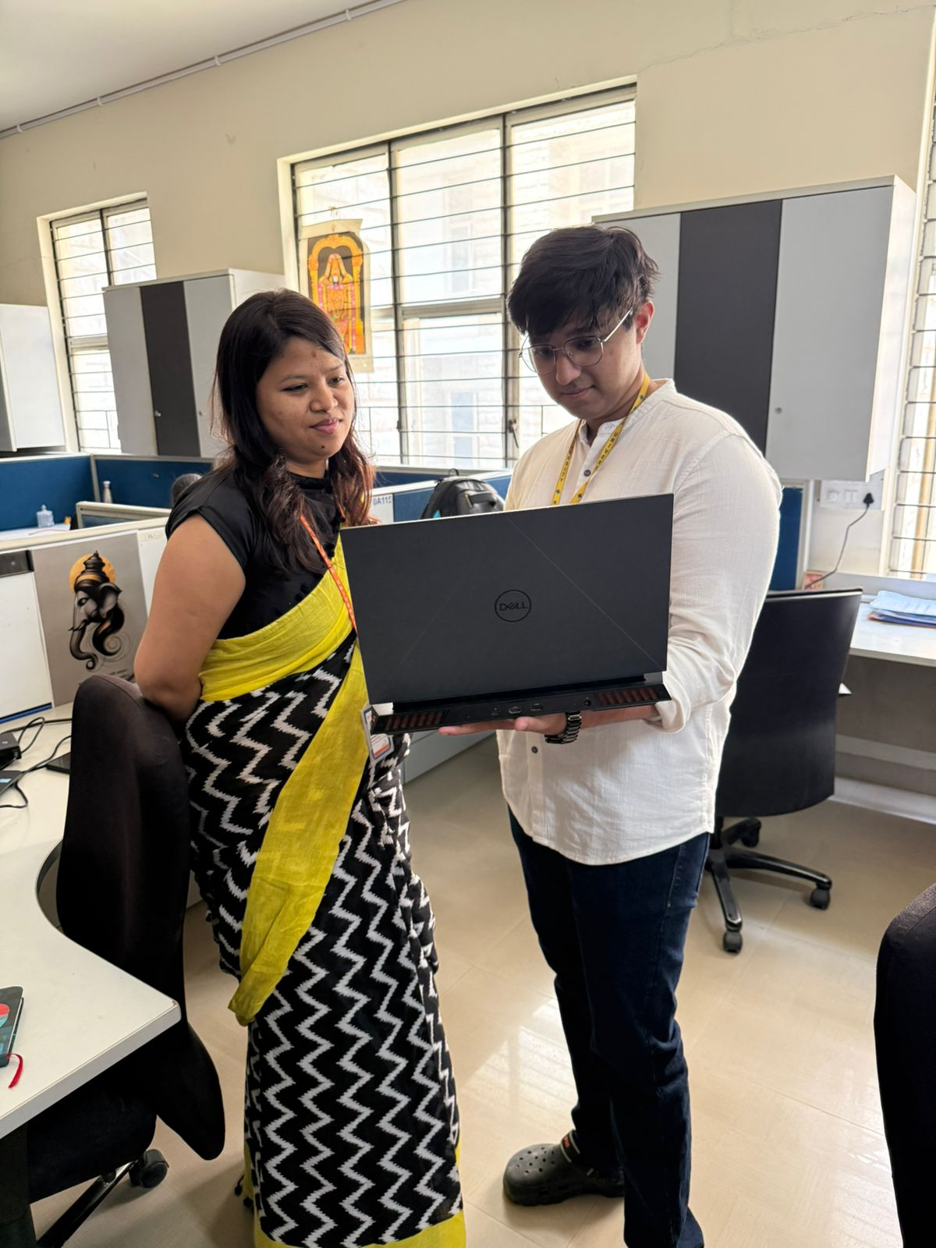
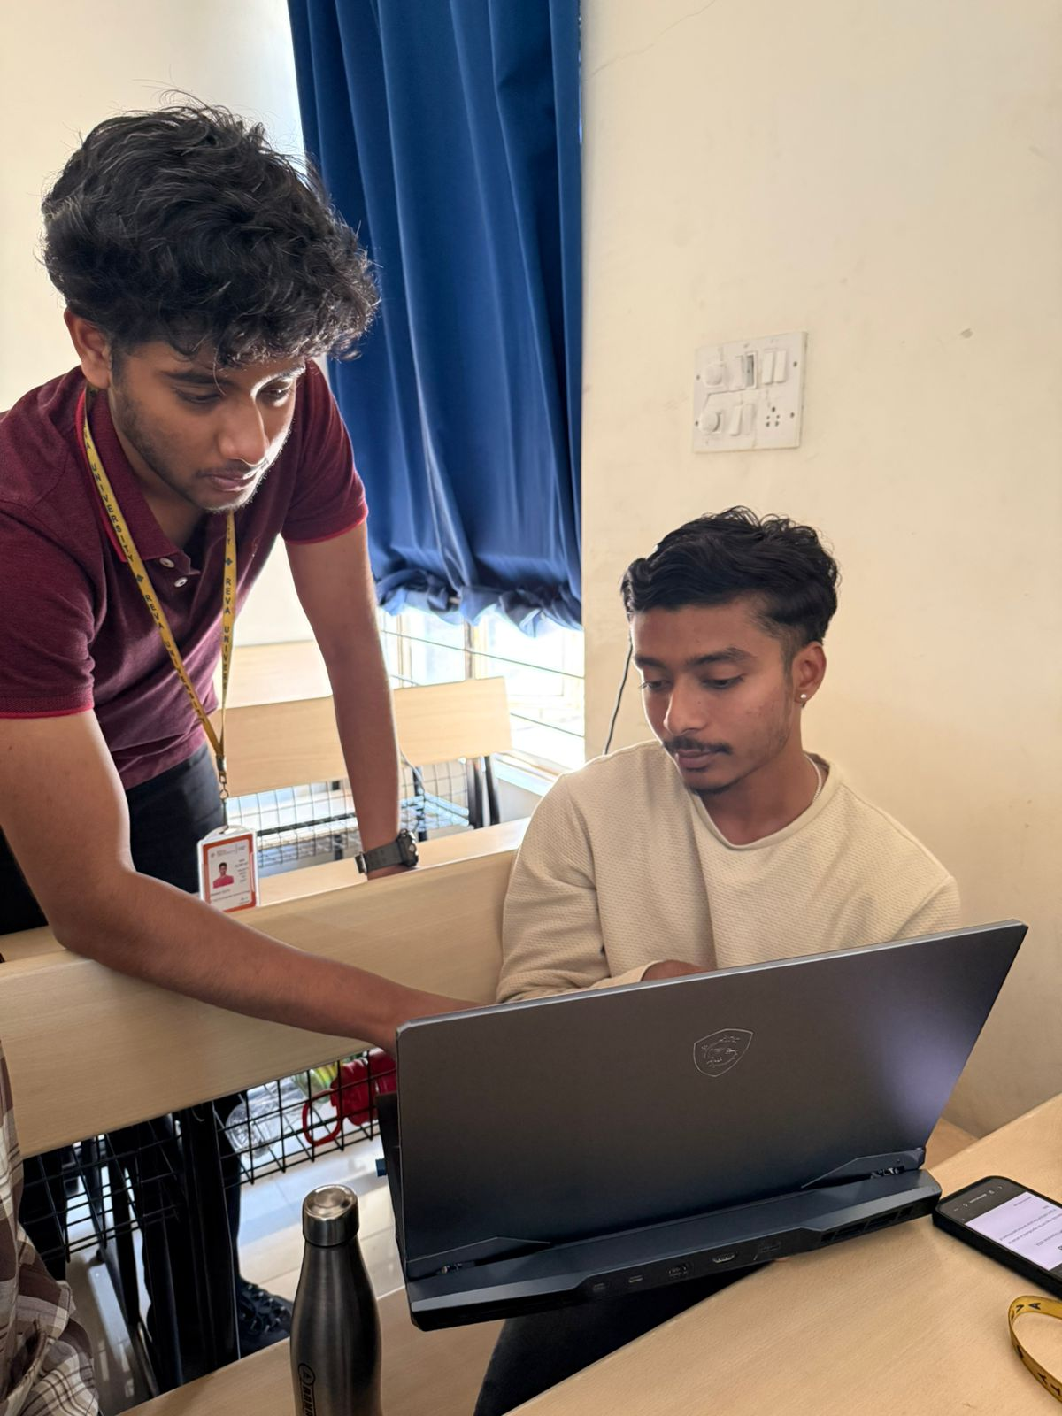
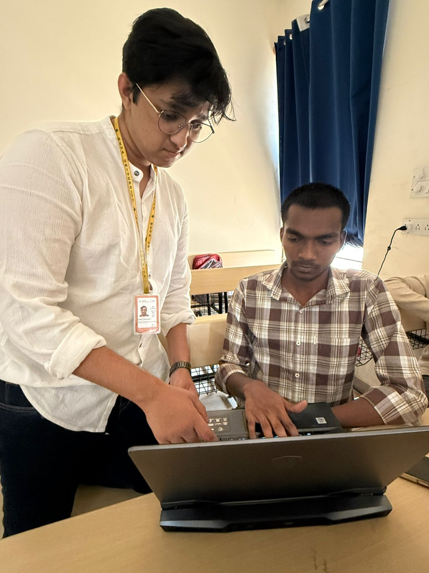
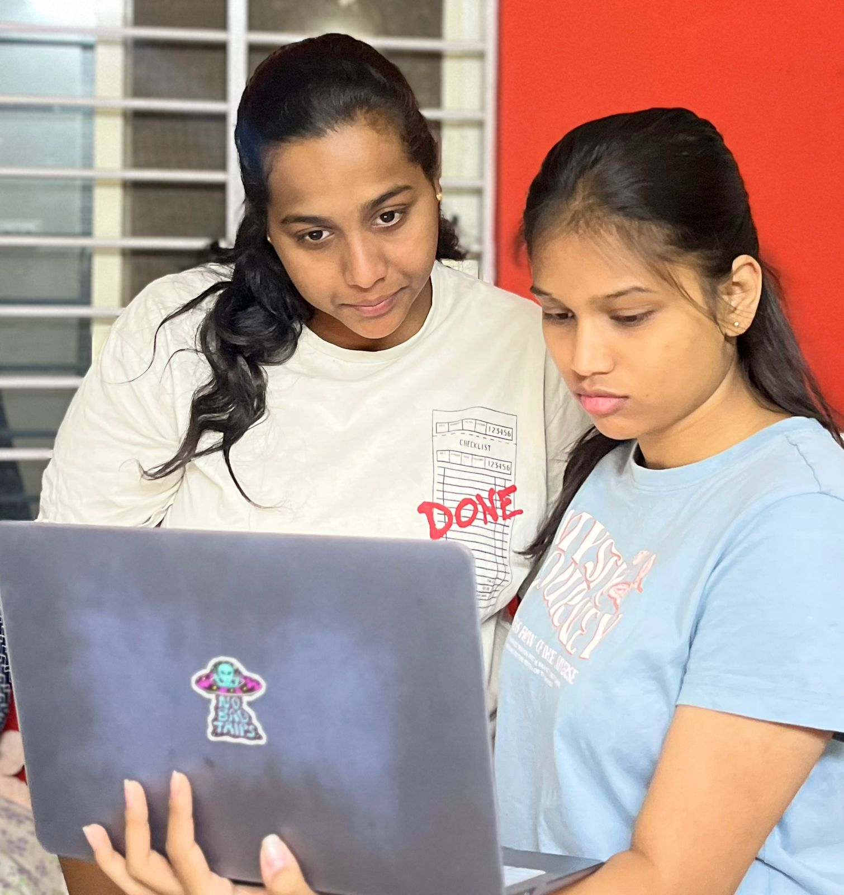


Customer Interview
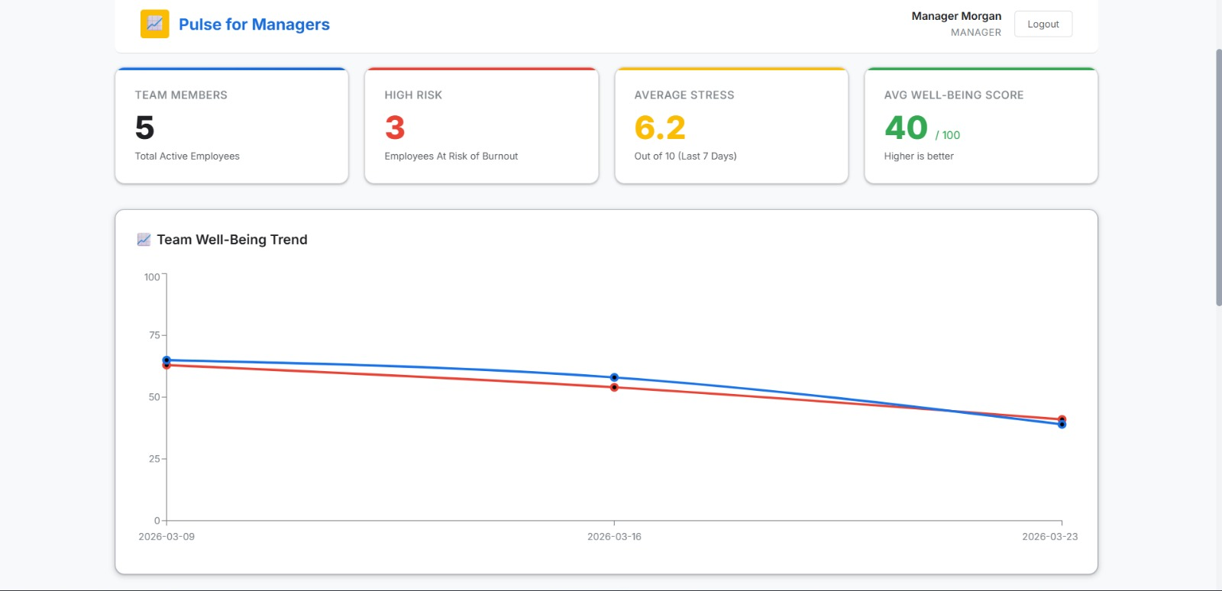
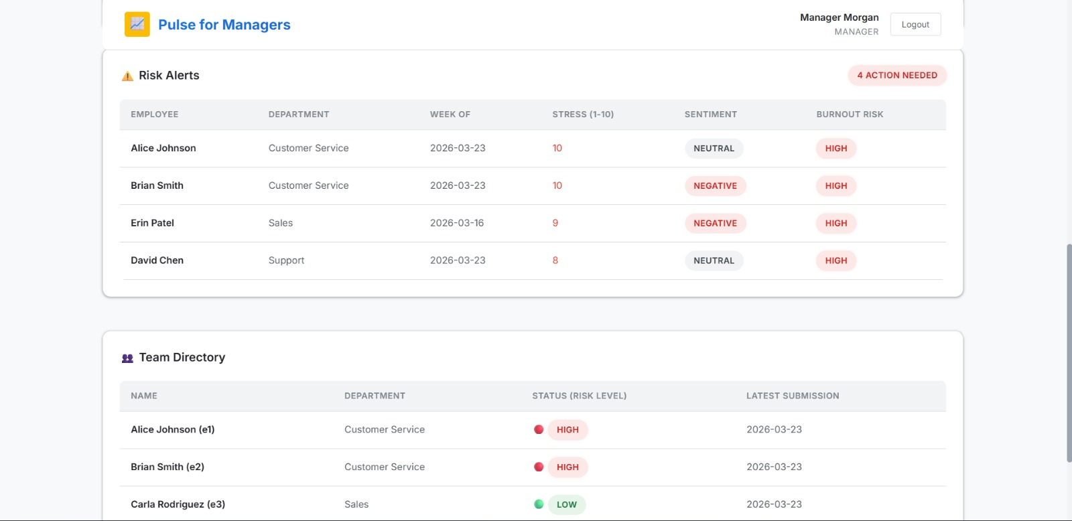
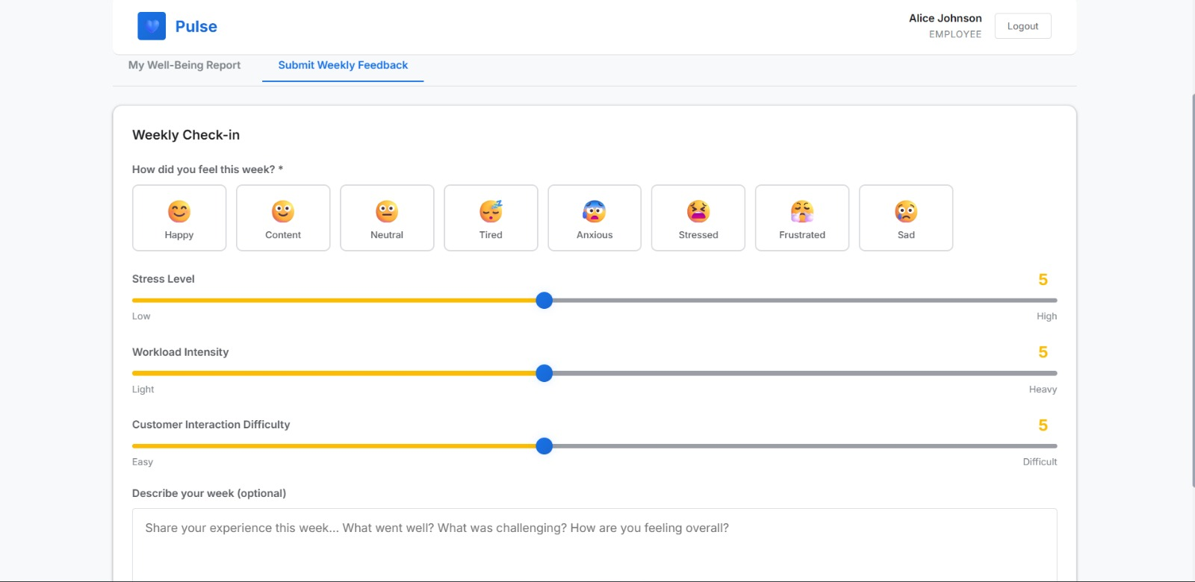
Survey:
Customer Interaction:

Customer Interaction:

Person 1:

Name: Ahaana Singh
Age: 21
Profession: CSA Student / Intern at a Real Estate Company

Background:

1. Works as a Business Development Executive at a real estate company.

2. Responsible for reaching out to potential clients, scheduling property discussions, and following up on leads.

Pain Points:

1. Managing multiple calls, meetings, and sales targets creates a packed schedule.

2. Constant coordination with clients and meeting deadlines can be stressful and tiring.

3. Maintaining consistent follow-ups with prospects requires significant time and effort.

Needs:

1. Better tools or systems to manage client communication and scheduling efficiently.

2. Improved support to balance workload and reduce stress during busy work periods.

3. Short breaks or recovery time to maintain productivity and focus.

Customer Interaction:

Person 2:

Name: Karthik
Age: 23
Profession: Senior Software Engineer (SDE II/III)

Background:

- Designs and develops complex software components, ensuring systems are efficient, scalable, and reliable.

- Mentors junior engineers by guiding them through technical problems, reviewing code, and promoting best development practices.

Pain Points:

- Difficulty balancing personal development tasks with mentoring and code review responsibilities.

- Pressure from tight deadlines and challenging technical issues.

Needs:

- Productivity and collaboration tools to streamline development and teamwork.

- Support for better work-life balance and stress management.

